Morgan Kennedy

Keegen Thompson

Alex Collazo

Vincent Nguyen

<= Use Mr. Tumulty’s face instead of smiley faces

Project 5

Prioritized List of Deliverables

1. > Developing the web page content without Javascript

Create 2 div tags that create a line down the middle of the page separating the two sides.

Done by: this Wednesday (11/16)

2. > Generating the left side images:

Make the images appear when the page is loaded.

Done by: end of Monday (11/21)

3. > Handling the right side:

Clone a copy of the images on the left side and add one extra that the user must find.

Done by: end of Friday (12/2)

4. > Finished the game:

If the user correctly finds the extra face, then add 5 more for the next round. If user is incorrect then alert the user that they have lost.

Done by: end of Tuesday (12/13)

Requirements Analysis

1. Where will the application run and what software (OS, applications, etc.) will the end user require in order to run it?

The application will run on Google Chrome

2. What hardware will the end user require in order to run your application?

Mouse, screen

3. How will the end user interact with the application (describe)?

The game is a matching game. The user will find and click the extra Mr. Tumulty face that appears on the left side of the line. If they don’t guess correctly, the game is over. If they do, they move on to the next round and five more faces are added. This goes until they guess incorrectly.

4. Create two high level Use Case Scenarios for this application

Scenario 1: User wins game round.

1. User presses start and game begins.
2. Five faces pop up on left side and six pop up on right side
3. User finds extra face on right side and clicks on it
4. Five more faces are added

Scenario 2: User loses game round

1. User presses start and begins game.

2.Five faces pop up an left side and six pop up on the right side

3. User fails to find the extra faces

4. No faces are added until the user completes the round correctly.

Entity Relation Diagrams

Part 1:Relationship between the left and right side:

Untitled Diagram.png

Part 2: Faces originally created:



Part 3: Where and how the faces are cloned:



Part 4: Event handler associated with extra faces on left side:ERD3.png

Part 5: Event handler associated with anywhere but the extra face on left side:

ERD4 (1).png

Application Mock Up

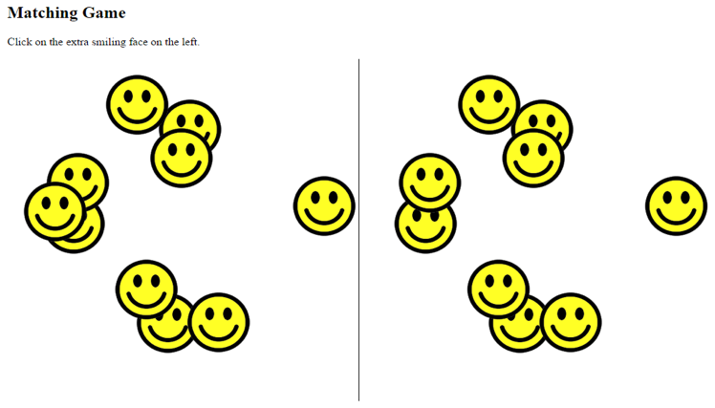 We will use Mr. Tumulty’s face instead of the smiley faces ->

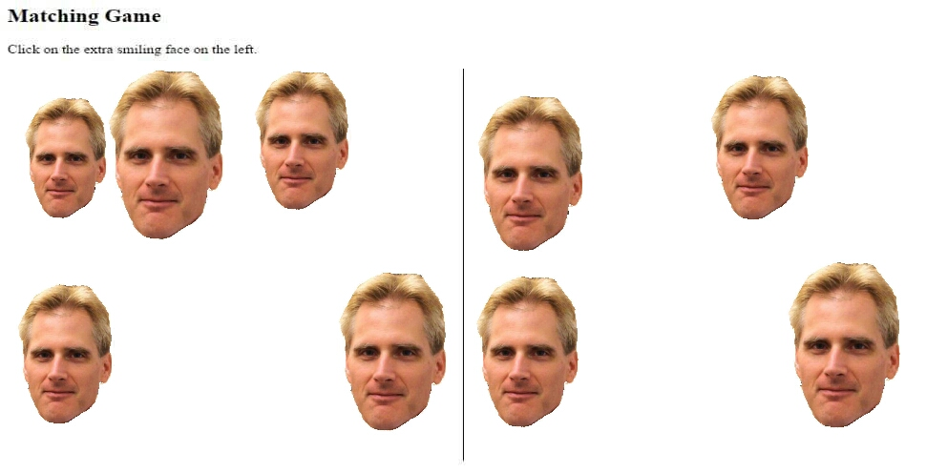

Flow ChartflowchartMatching.png